Risk Lab Application Overview
Prod URL: https://risklab.heartland.us
ZsysRole Required: RiskLab App
The RiskLab users will have to first login into the Servicing application; the way they login today is by entering Username and Password.
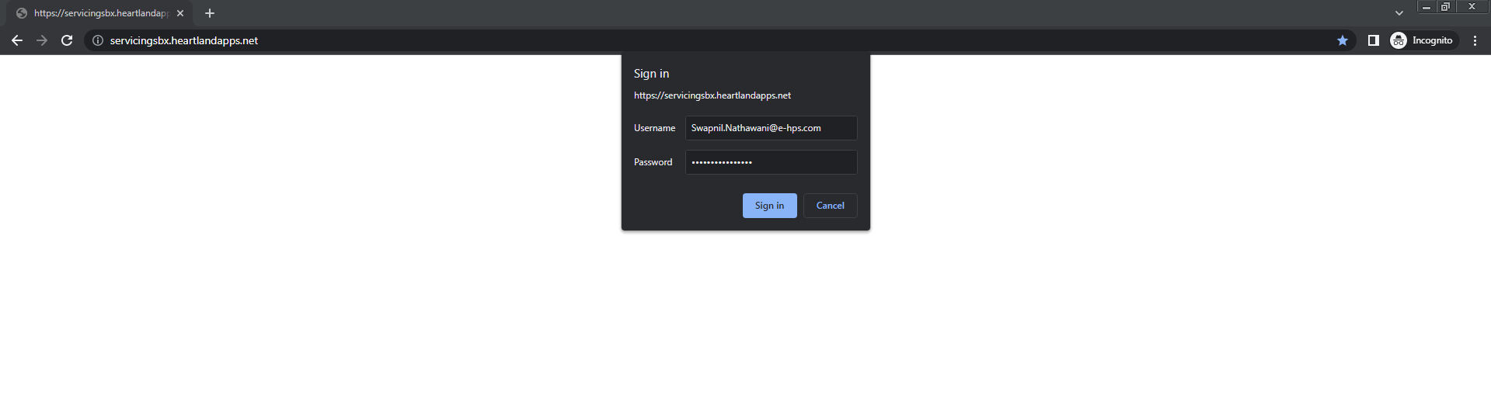
Once logged in, users would be landed on the Servicing Home page as below.
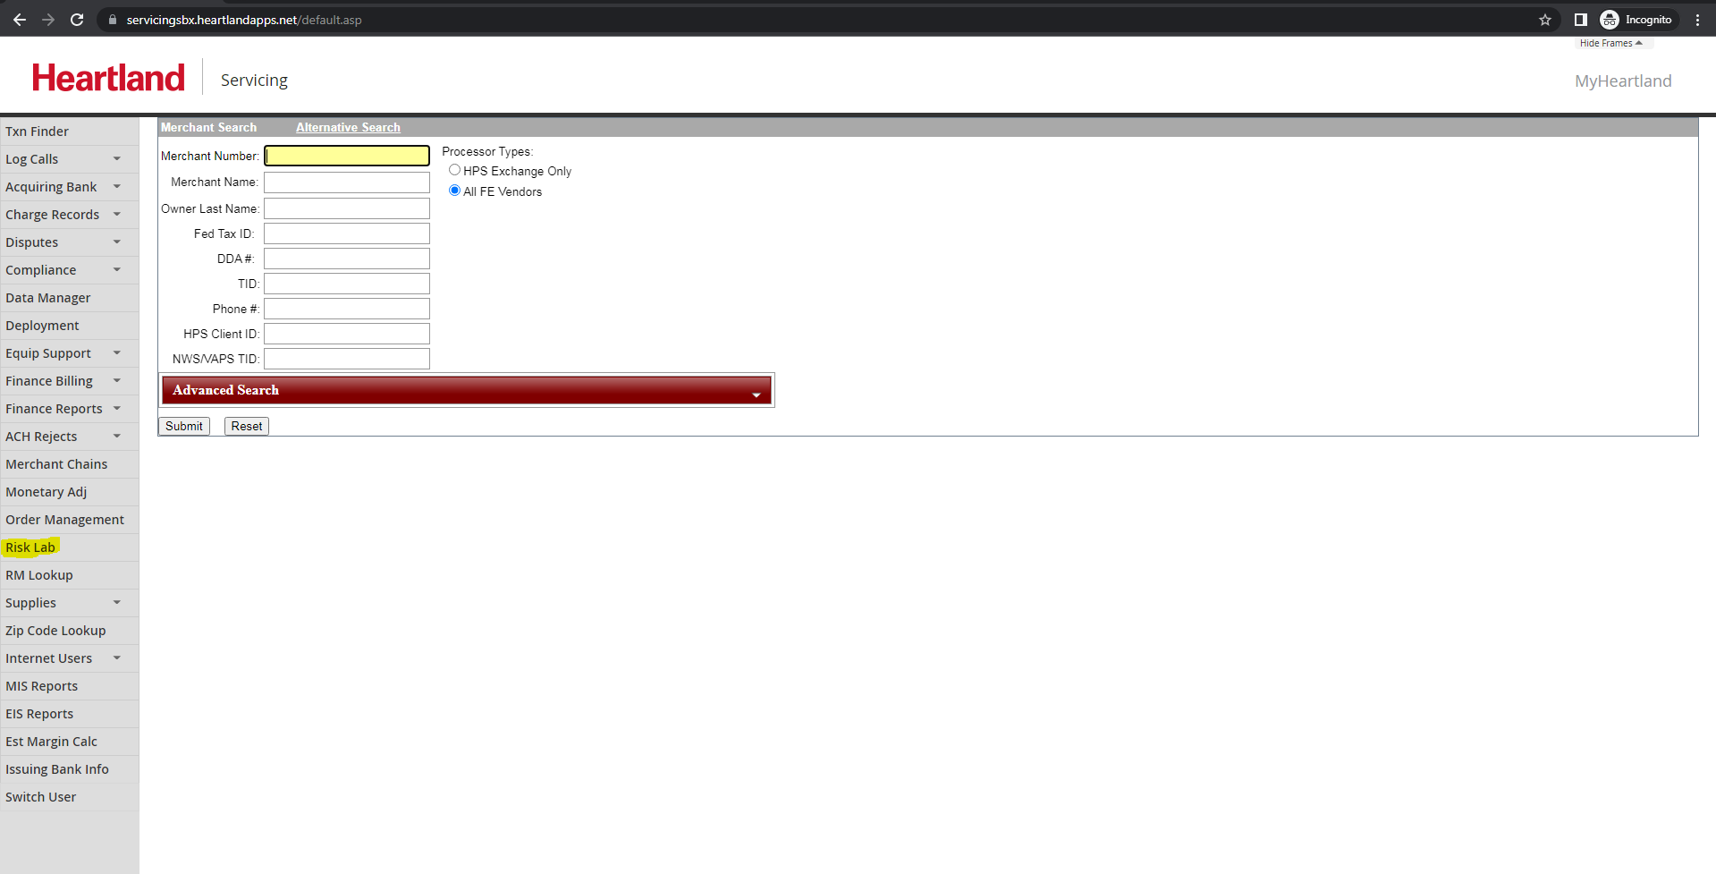
Only Risklab users would be able to see the Risk Lab option on the left menu bar on the Servicing UI. It is a role based functionality and would be restricted to specific users.
Clicking on the Risk Lab menu should direct the user to a separate portal in the new browser tab.
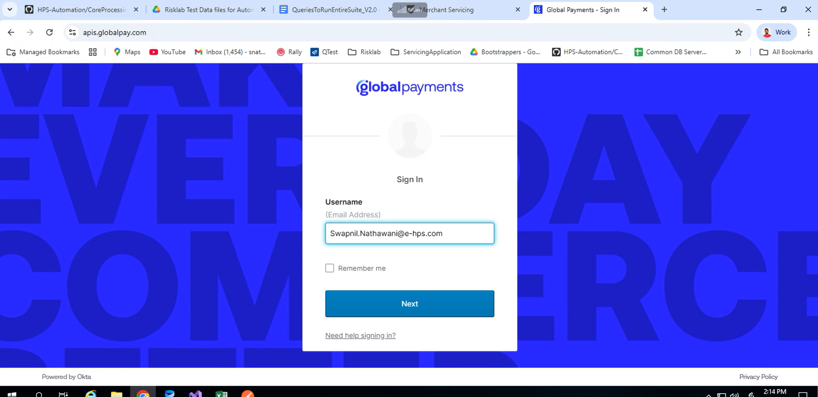
The user needs to enter the HPS email address in the Username field and Click on Next button. HPS email address is a mandate since it is driven from Servicing.
Now users will have to again enter the HPS credentials for AzureAD authentication.
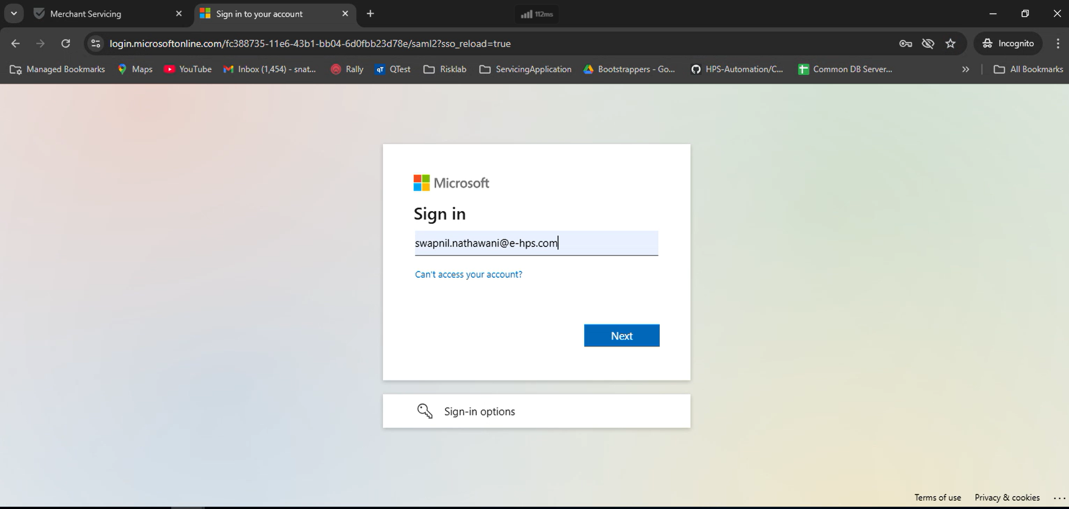
Enter the Password and Click on SignIn button
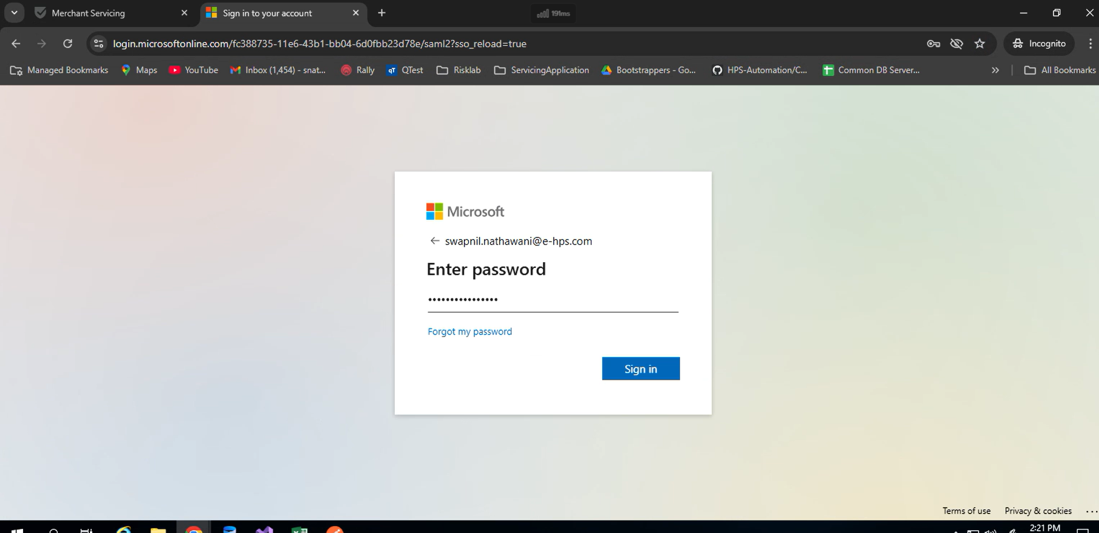
Users can select any option YES or NO; which will redirect the user to the Risk Lab home page.
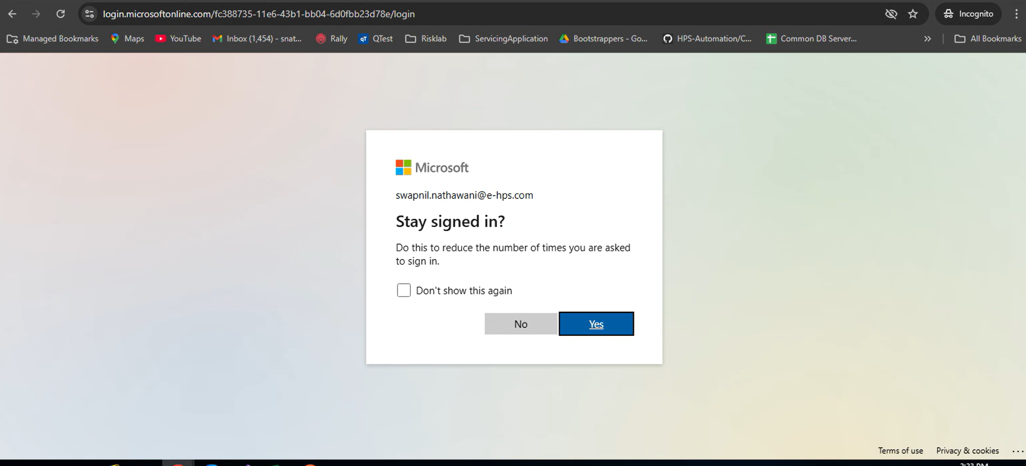
Left Menu Bar

On the left menu bar user would have options to navigate between Risk Rejects page or Fraud Service Details page:
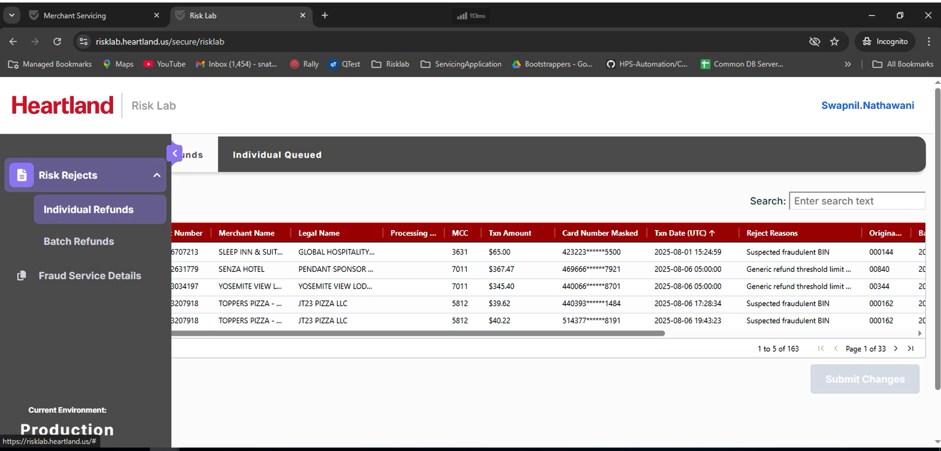
The selected option will be highlighted as above.

RISK REJECTS

This option has further 2 options like Individual Refunds and Batch Refunds each page has 2 tabs.
Individual Refunds have Rejected Individual Refunds and Individual Queued tabs.

Rejected Individual Refunds
Users land on the Rejected Individual Refunds page by default after login into the Risklab application.
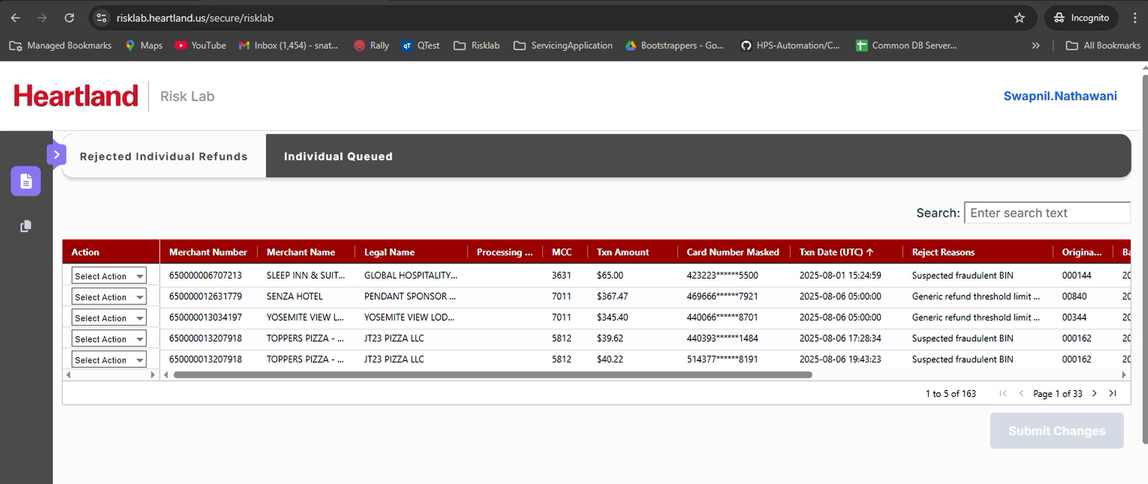
On this page users can see and take action on Rejected Individuals refunds transactions.
Users can perform three actions - Released, Deleted and Queued on the Rejected Individuals refunds by selecting the value from the dropdown against each transaction.
Users would be able to see a maximum of 5 transactions on a single Page.
Queue should populate in order from oldest refund date to newest by default.
Users can sort the queue by any displayed field.
Users can use the search textbox to search the queue by any field.
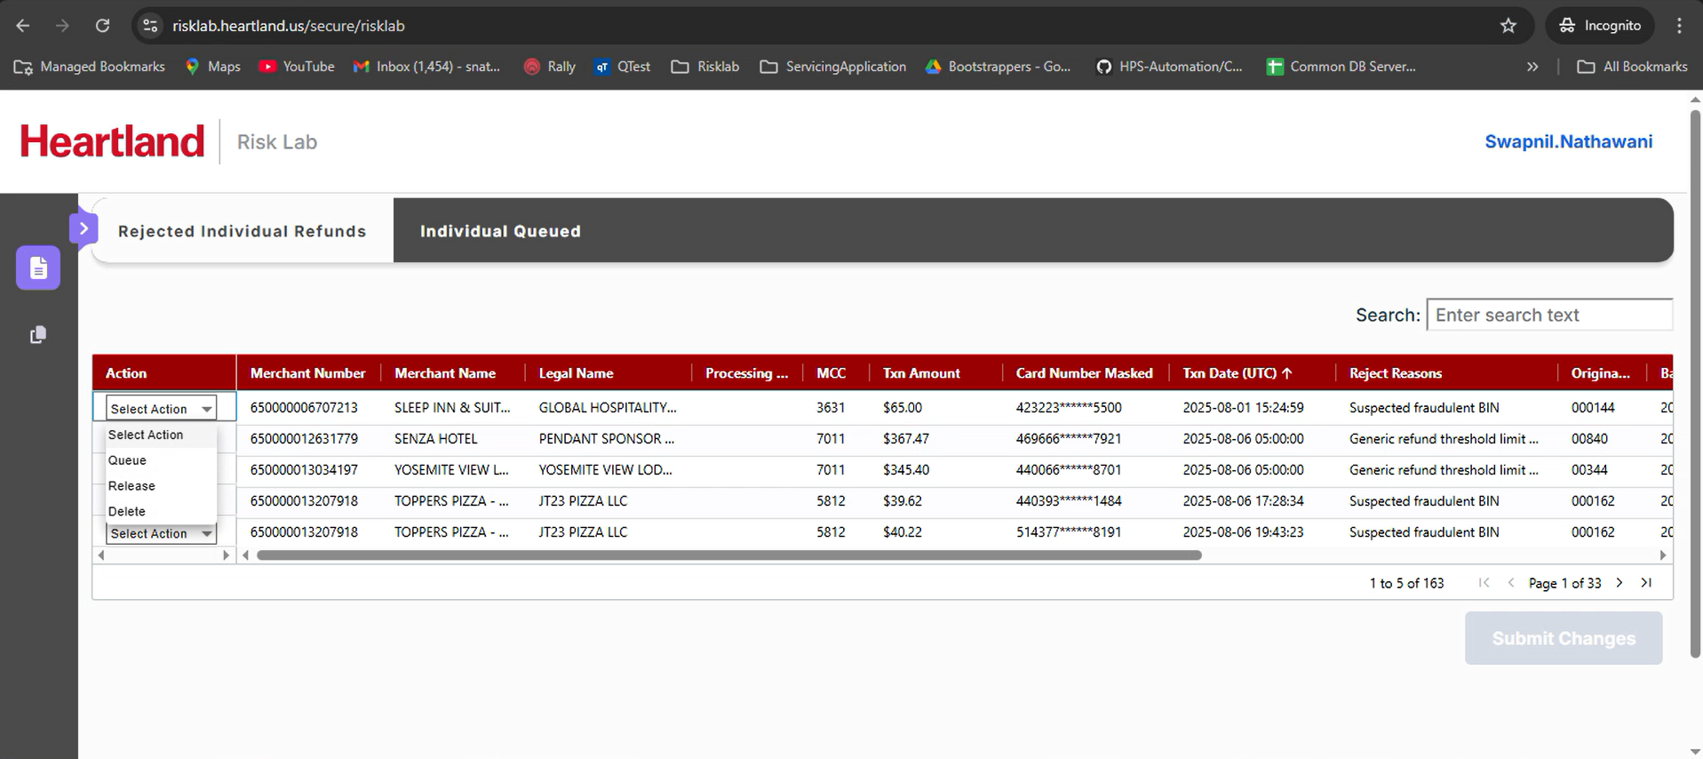
The Submit button would be disabled until the User takes action on all the transactions displayed on the current page.
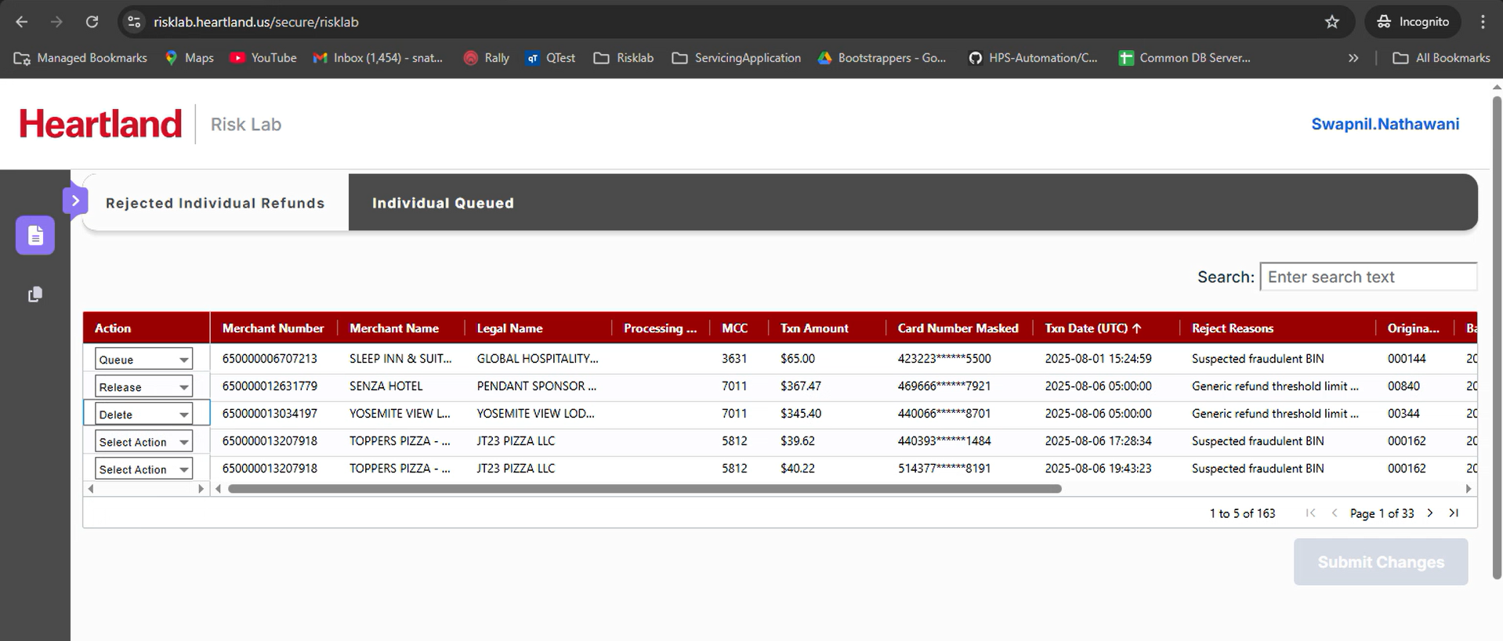
Submit Changes button will be enabled only when the Action column has a value selected from the dropdown for all transactions displayed on a page.
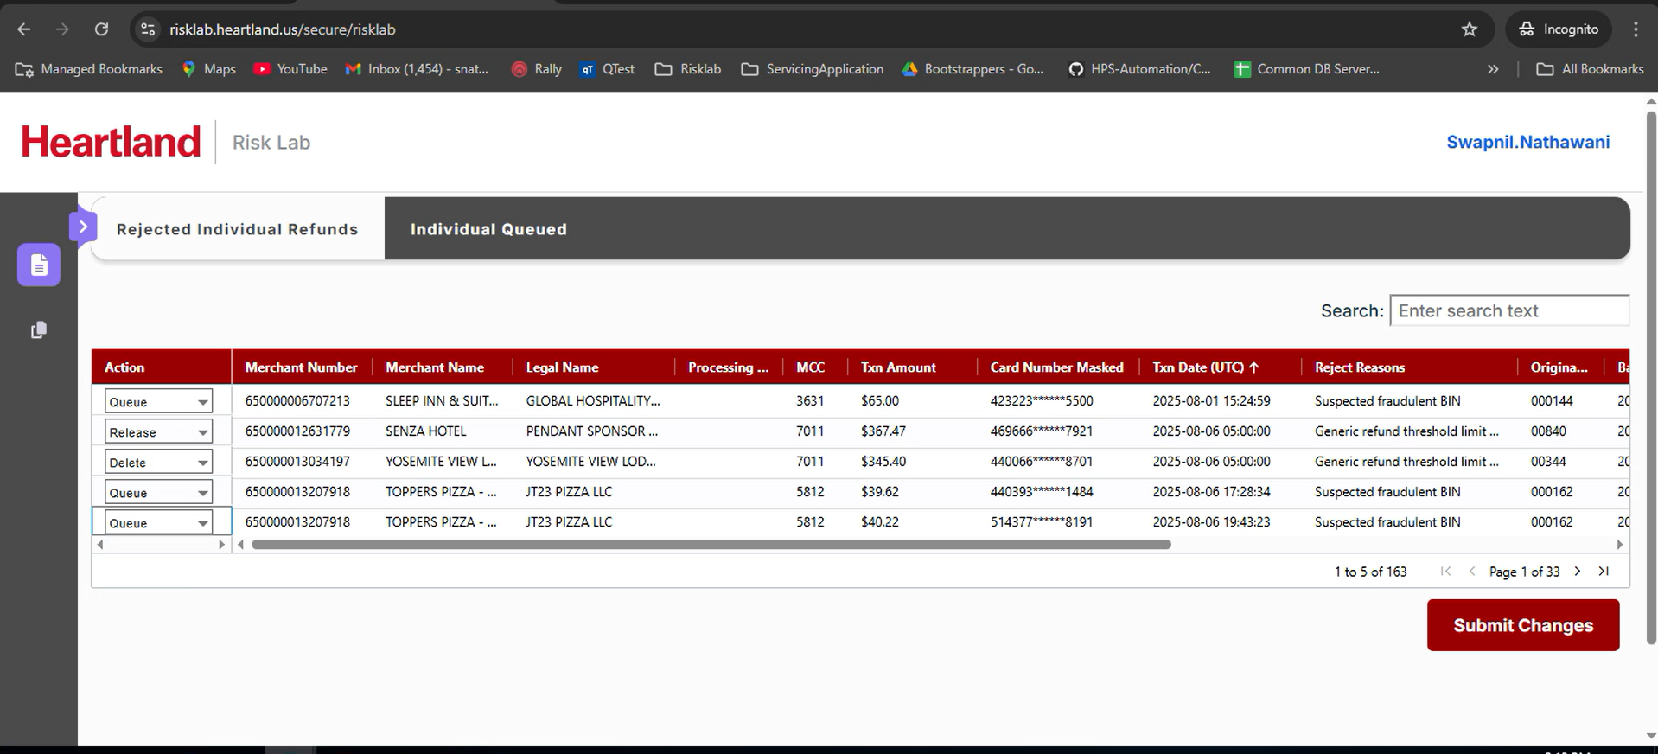
Once a user clicks on the Submit Changes button; a confirmation pop up is displayed on the page, where users should click on the YES or NO button.
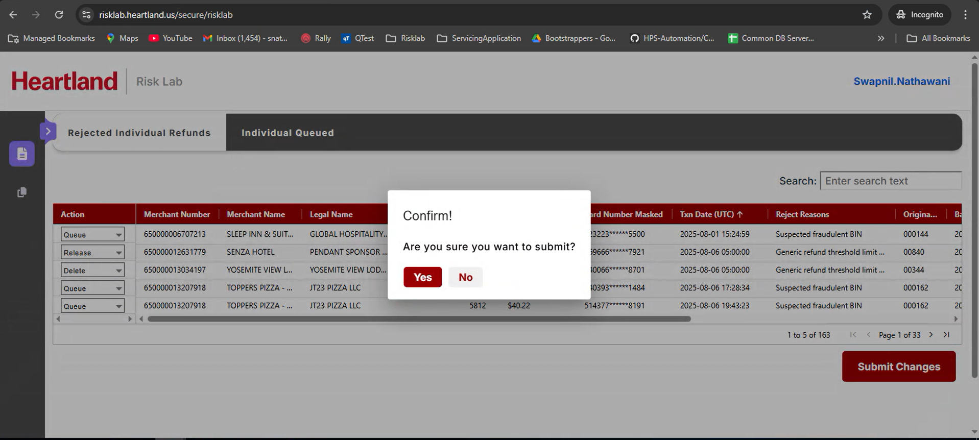
Once users click on the YES button, changes would be updated and these transactions would not be displayed on the Rejected Individual Refunds page.
- Released transactions would be sent to Passport through RabbitMQ.
- Queued transactions would be moved to the Queued tab to take action in future.
- Deleted transactions would be marked as Deleted in Database.

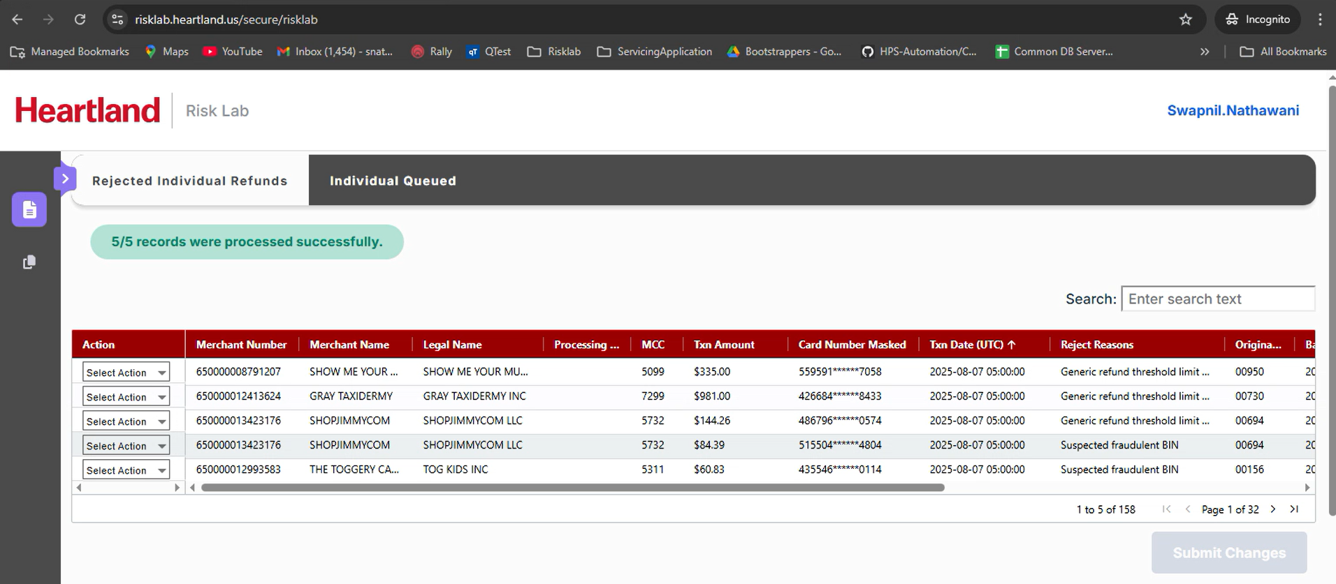Once changes are submitted, success messages will be shown and the transactions will be soft deleted from the UI.

Queued Refunds
All the transactions marked as Queued on the Rejected Individual Refunds page would be displayed on the Queued Page.
Users can perform two actions - Released and Deleted by selecting the value from the dropdown against each transaction.
Users would be able to see a maximum of 5 transactions on a single Page.
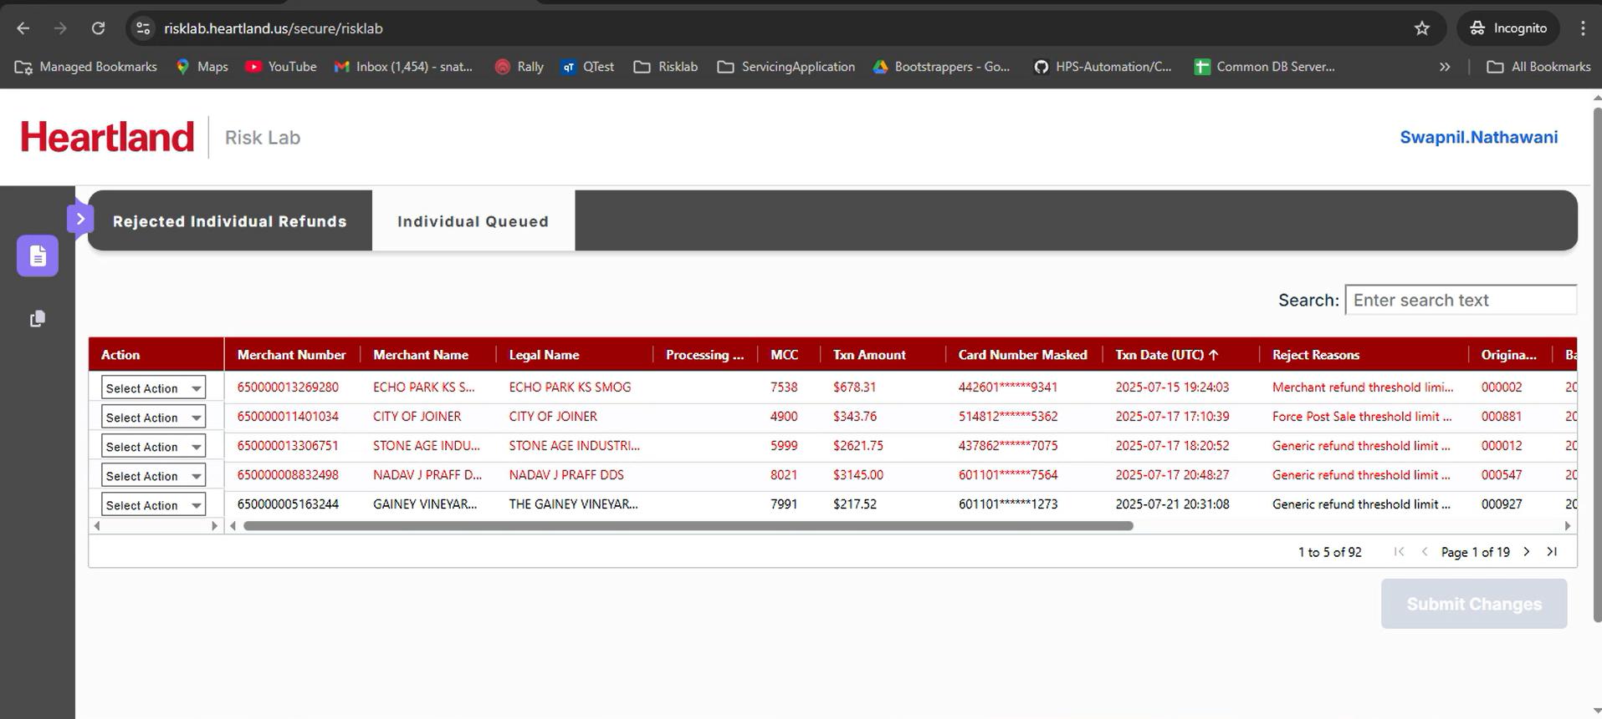
On the Queued page users must have to take an action on at least a single transaction to enable the Submit Changes button.
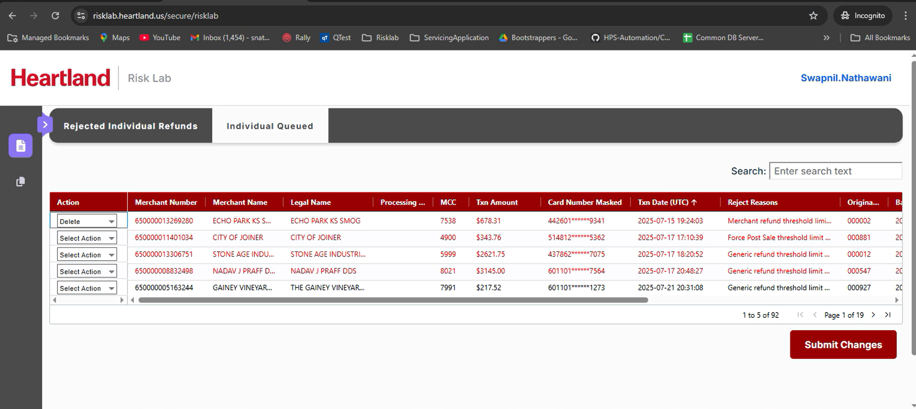
The remaining process remains the same as the Rejected Individual Refunds page.
Batch Refunds Page have Rejected Batch refunds and Batch Queued tabs
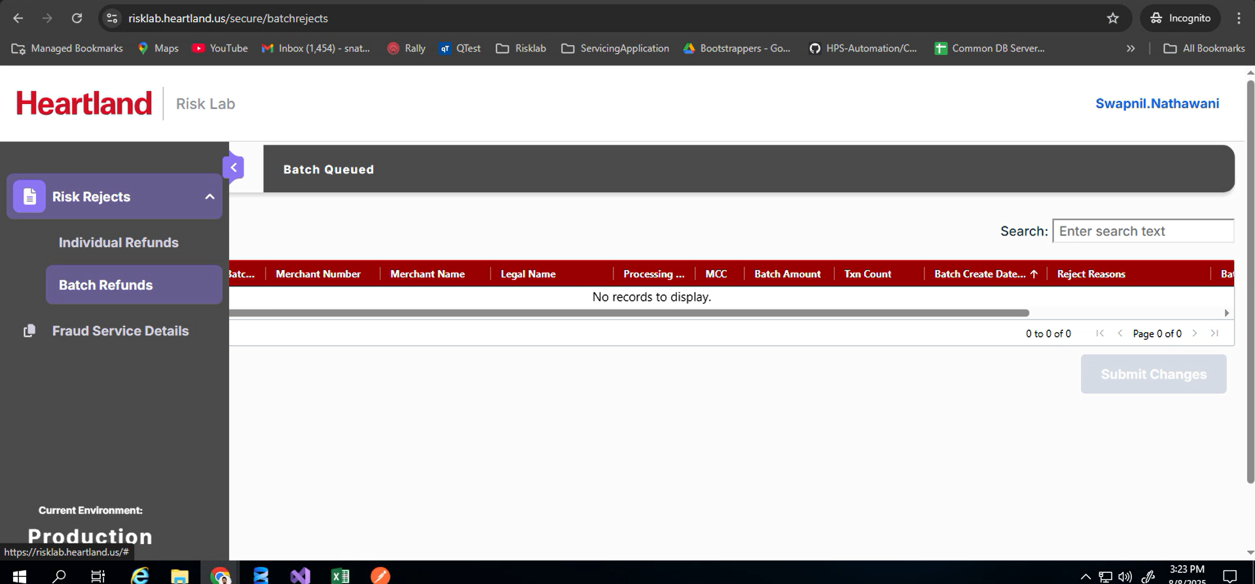
Rejected Batch refunds
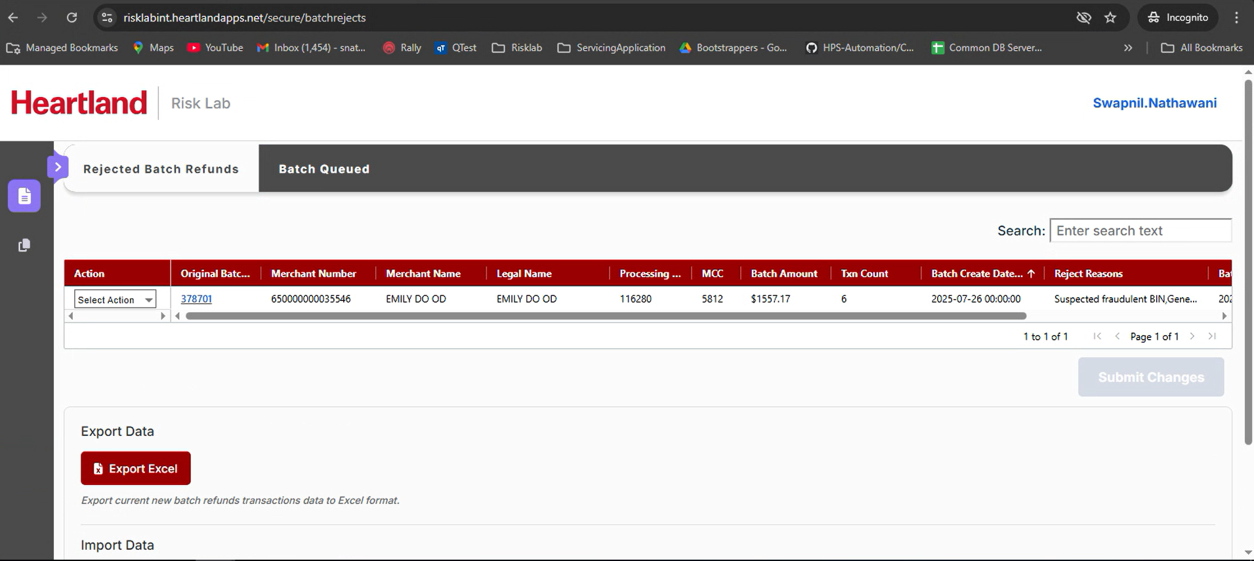
On this page users can see and take action on Batch refunds transactions.
Users can take action for the entire batch and perform three actions - Released, Deleted and Queued on the Rejected Batch refunds by selecting the value from the dropdown against each transaction.
Users would be able to see a maximum of 1 batch on a single Page.
Users can click on the Original Batch Number hyperlink, this will open a new tab where you can see all the transactions under that batch.
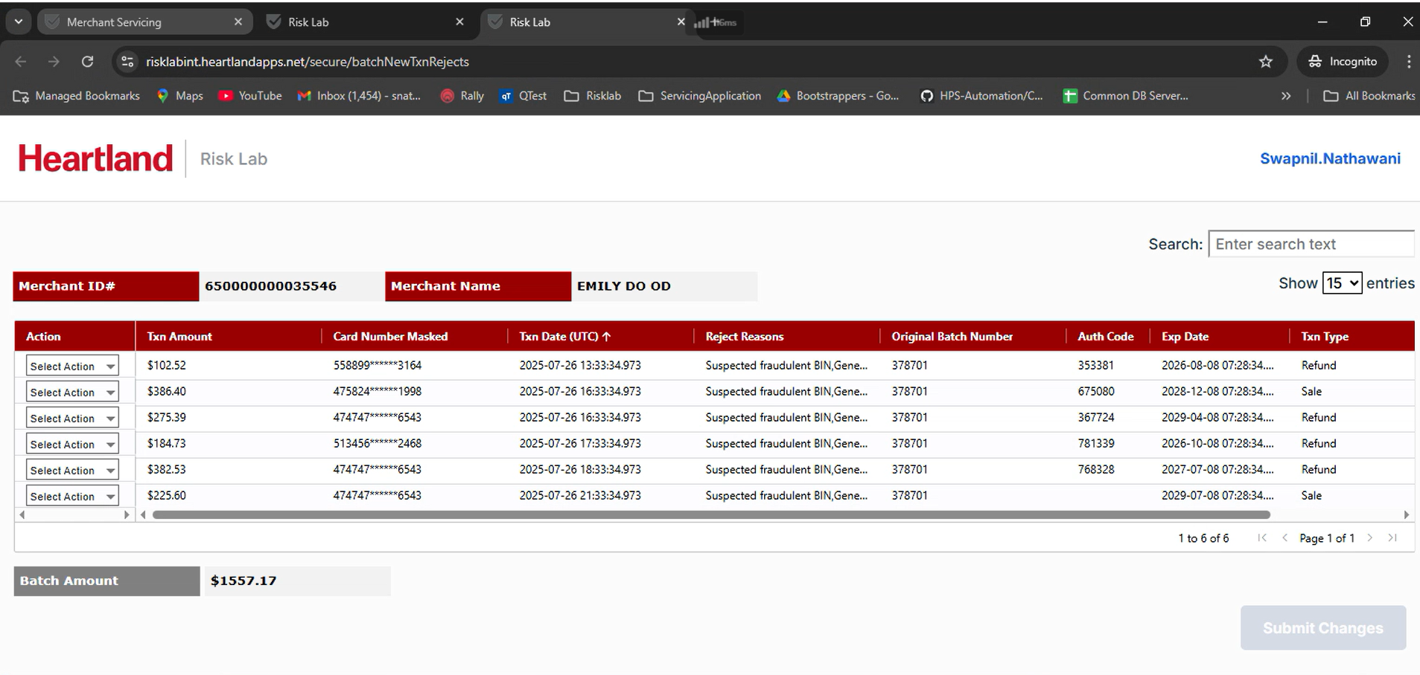
Users can take action at transaction level on this page. But then they won't be able to take action at batch level.
Batch Queued
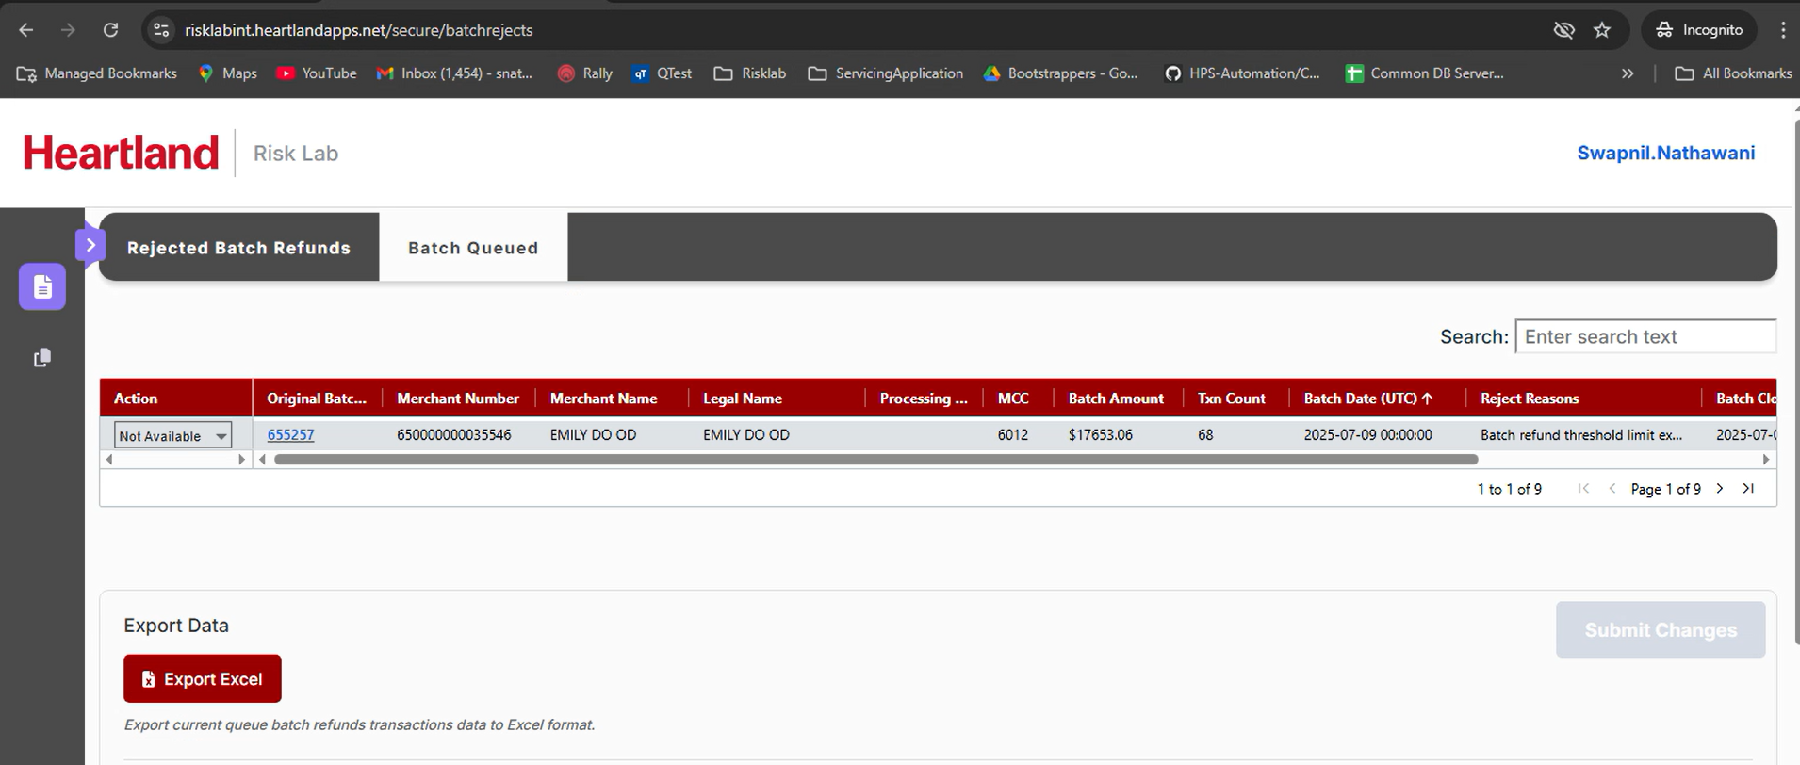
Users can take action for the entire batch and perform two actions - Released or Deleted on the Queued Batch refunds by selecting the value from the dropdown against each transaction.
Users would be able to see a maximum of 1 batch on a single Page.
Users can click on the Original Batch Number hyperlink, this will open a new tab where you can see all the transactions under that batch.
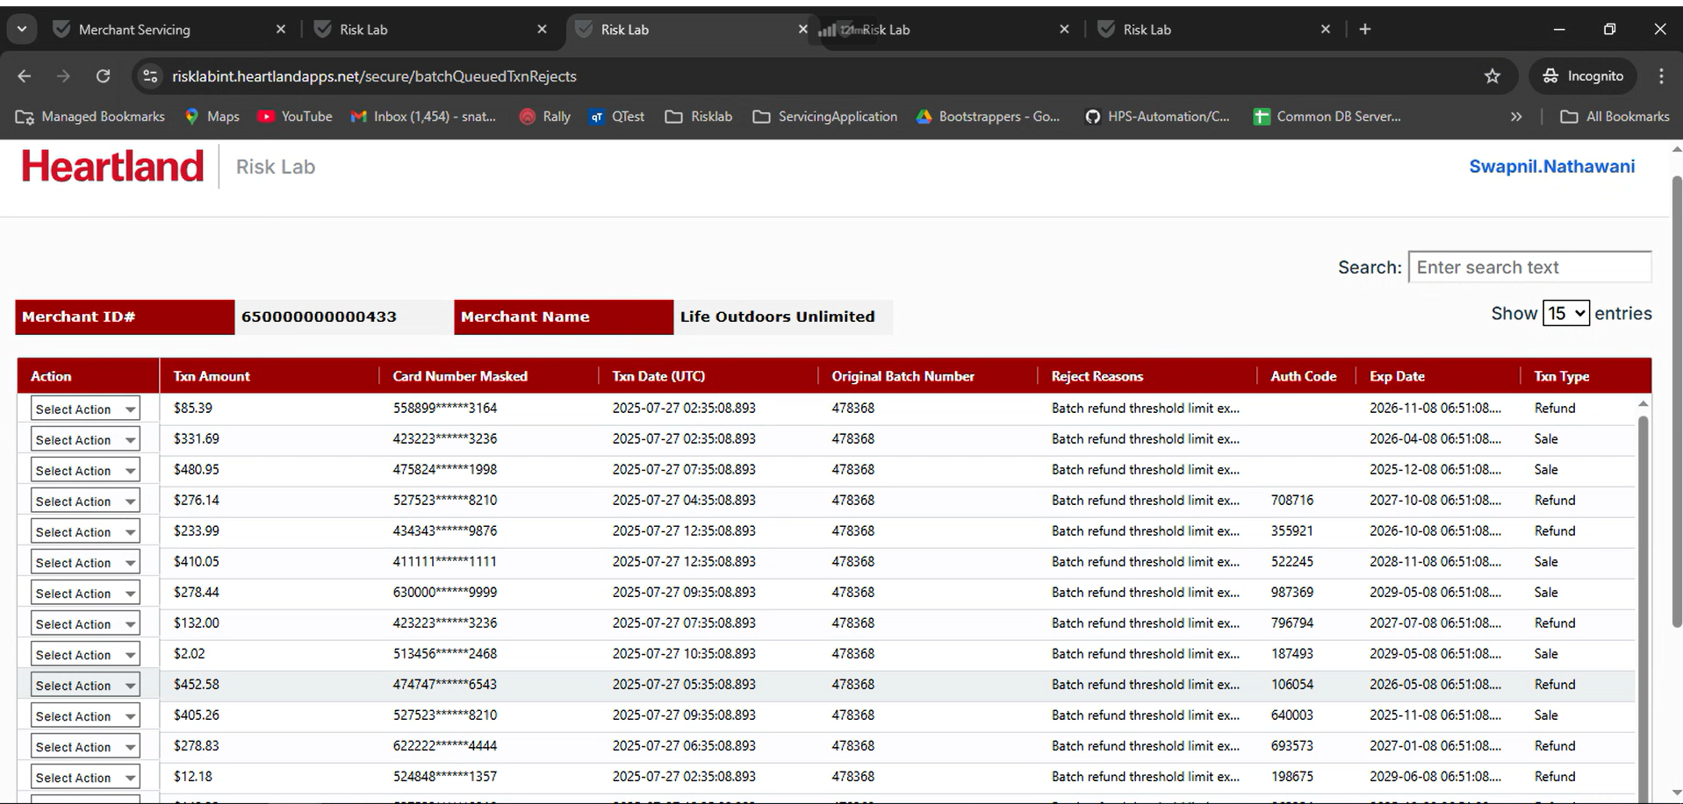
SEARCH Functionality
Using search functionality, users can search with any field and filtered transactions would be displayed on the page. Users can either take an action on all displayed transactions or clearing search users can return to the previous view.
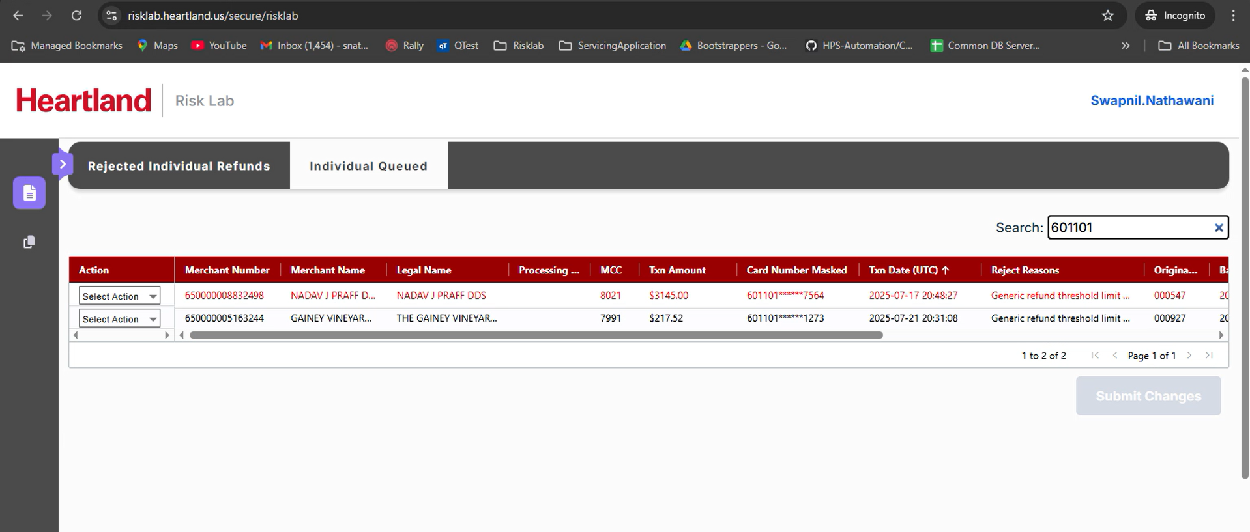
User can select a value from dropdown and the Submit Changes button will be enabled:
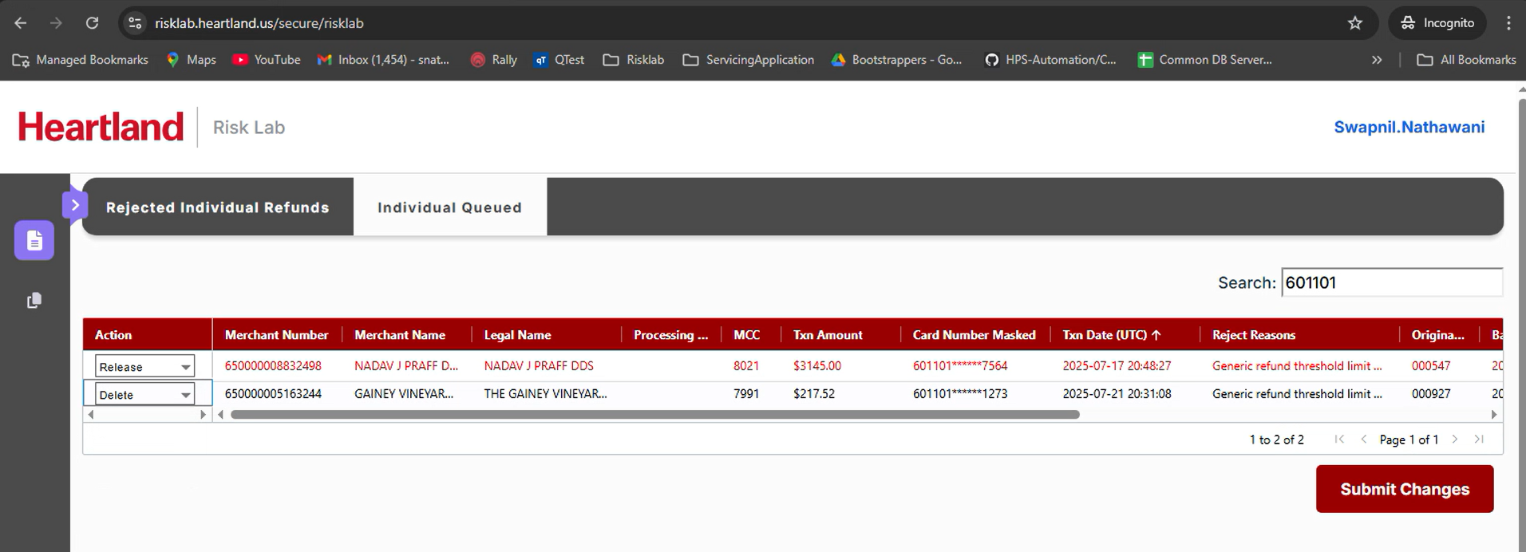
On both the tabs you can see a few transactions are highlighted with red color font as below:
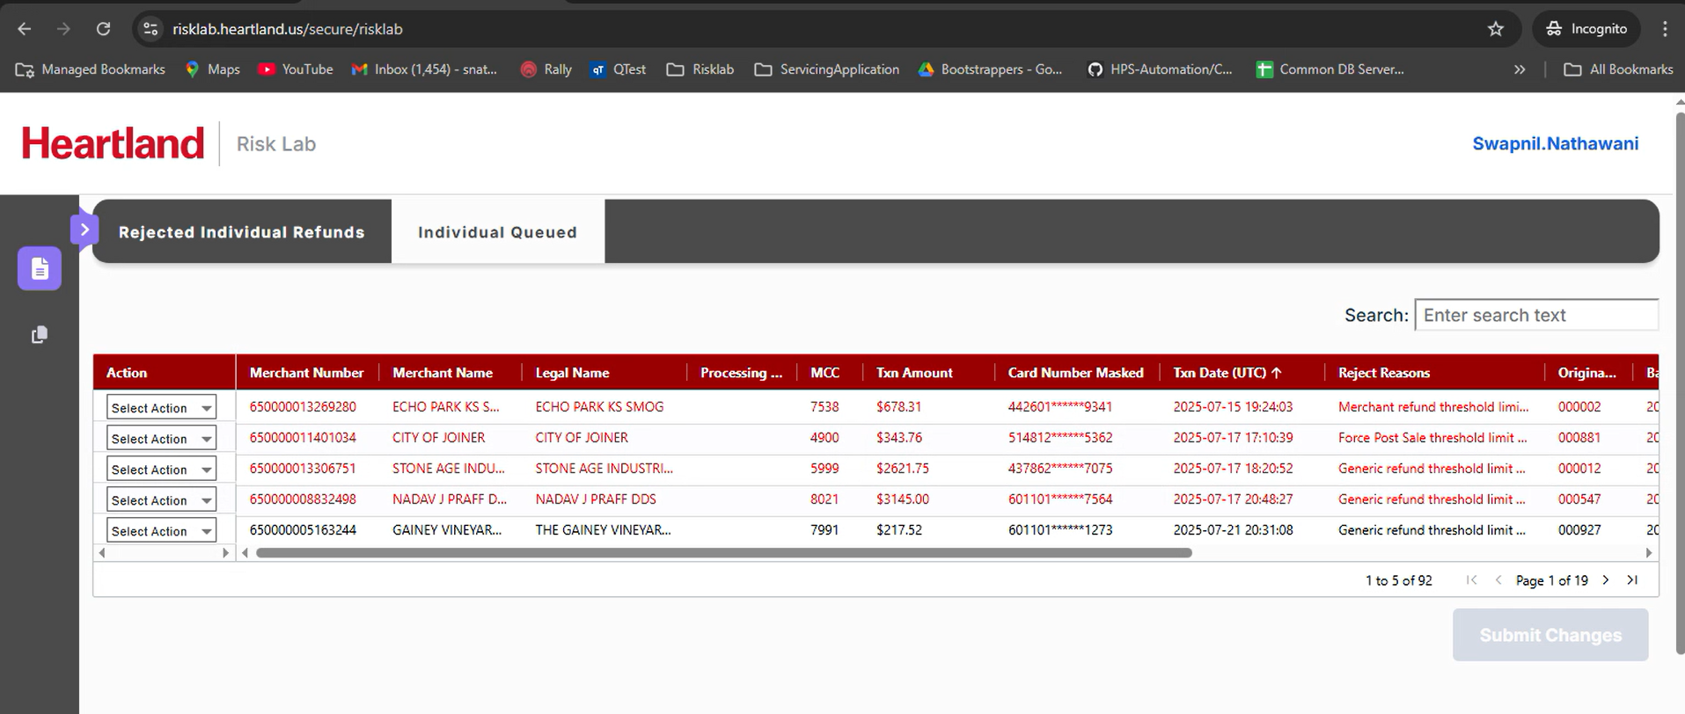
Whenever there are unsaved changes and user tried to move away from page we show this pop up:
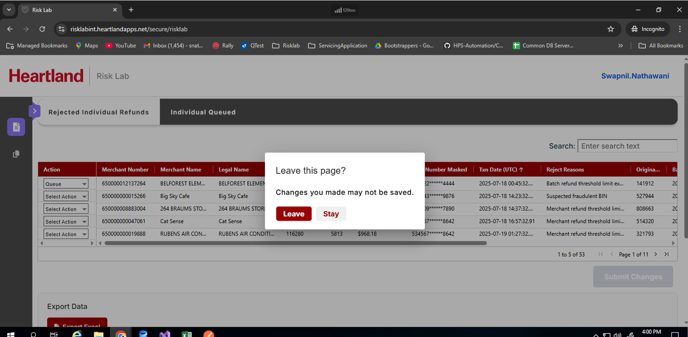
Fraud Service Details
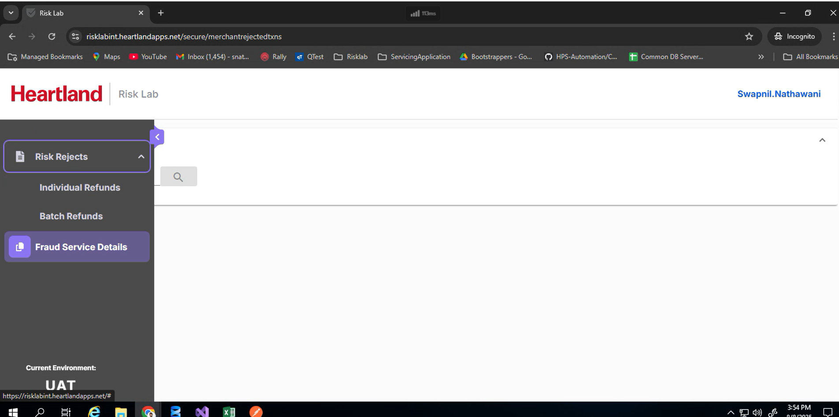
On this page users need to enter a MerchantNumber to see all the transactions for a particular merchant.
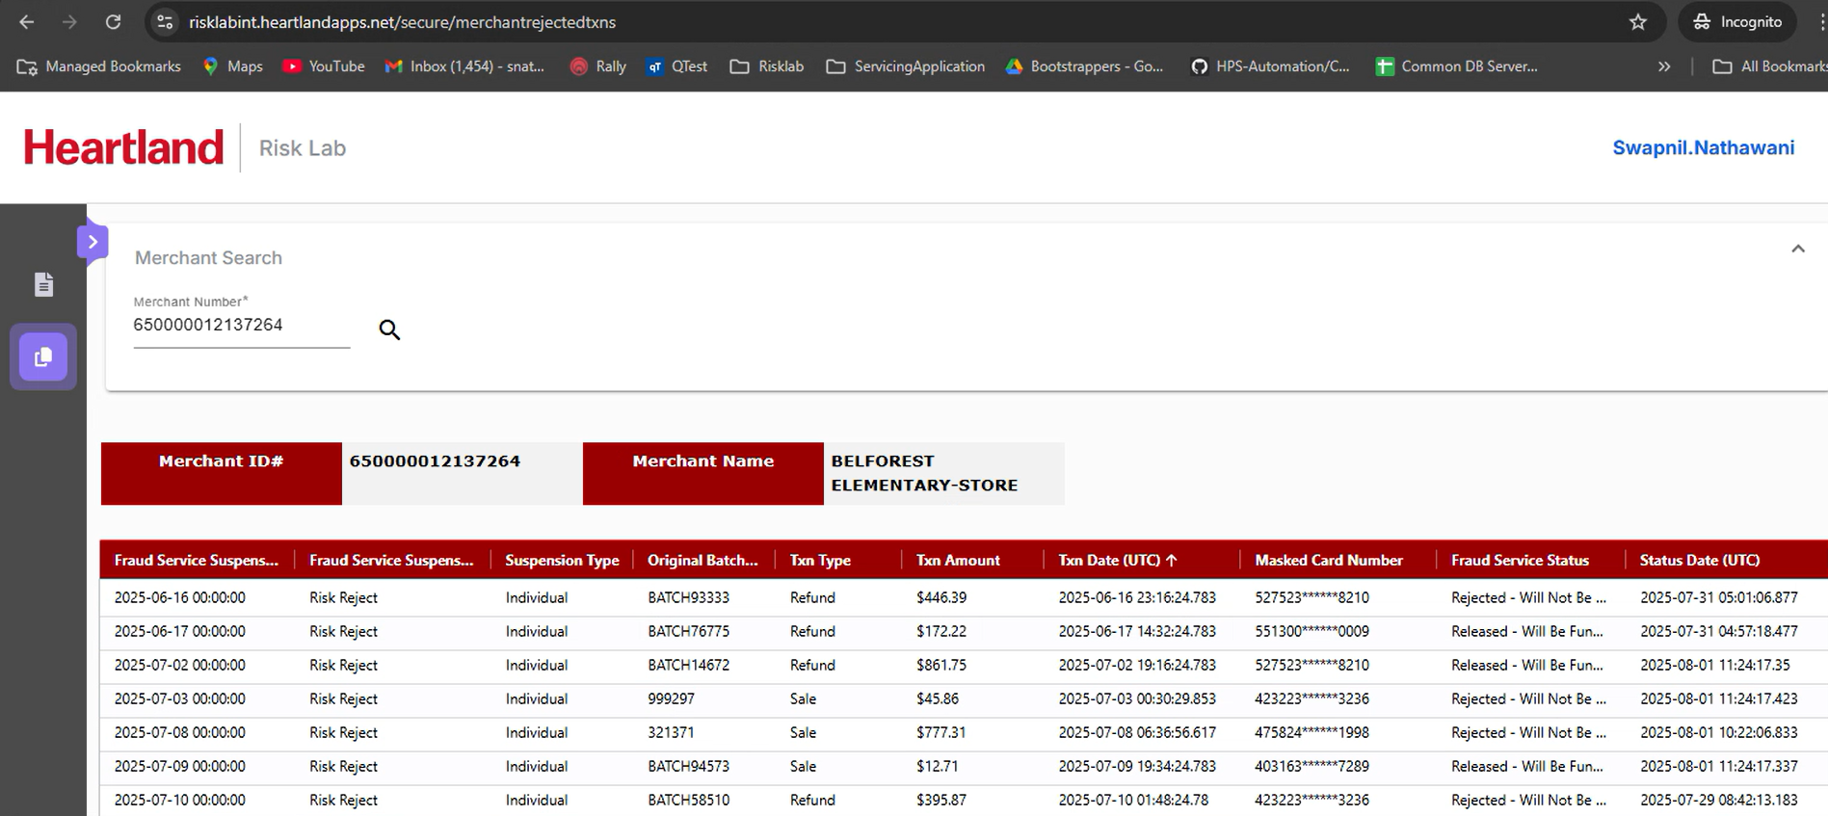
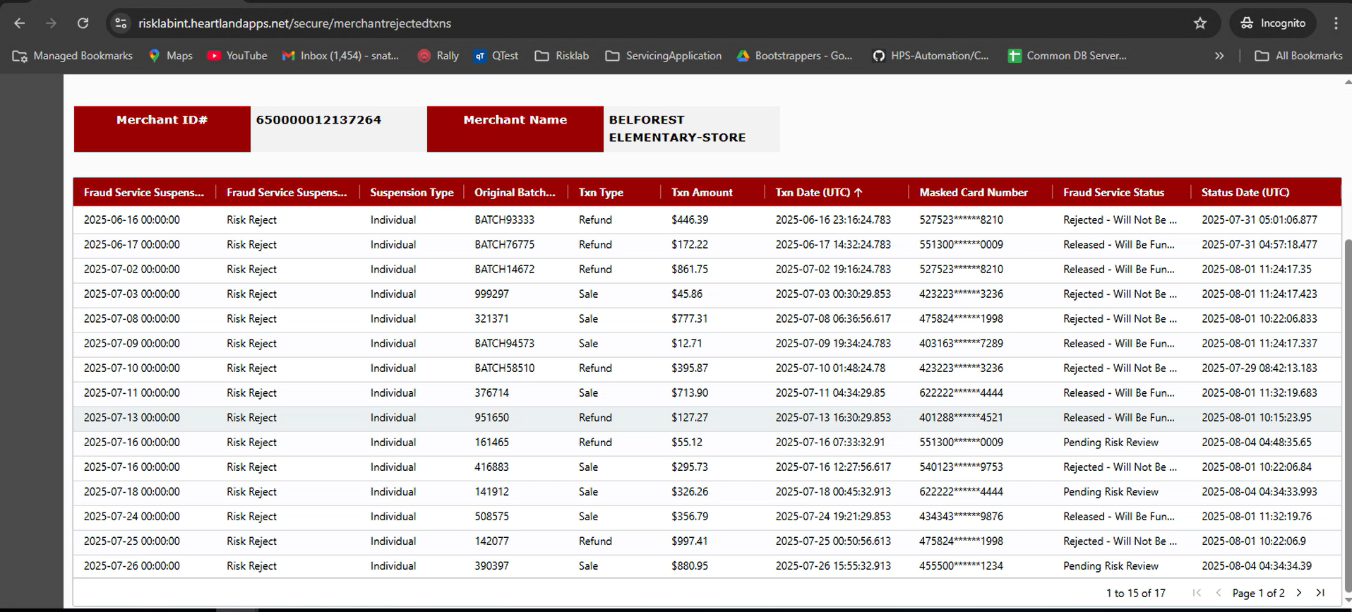

Logout
Users can logout from the application using the logout option below the logged in UserName
